STM32 Computer

Introduction
STM32MP15XXAC

Formulas

Critical length

Impedance

Stack
The stack is JLC04161H-1080 with finished thickness 1.52 mm.
Layer | Material | Thickness (mil) | Thickness (mm)
L1 | Outer Copper Weight 1oz | 1.38 | 0.0350
Prepreg | 1080 RC67% 3.3mil, ε = 3.91 | 3.01 | 0.0764
L2 | Inner Cooper Weight 0.5oz | 0.60 | 0.0152
Core | 1.3mm H/HOZ with copper, ε = 3.91 | 49.80 | 1.2650
L3 | Inner Cooper Weight 0.5oz | 0.60 | 0.0152
Prepreg | 1080 RC67% 3.3mil, ε = 3.91 | 3.01 | 0.0764
L4 | Outer Copper Weight 1oz | 1.38 | 0.0350

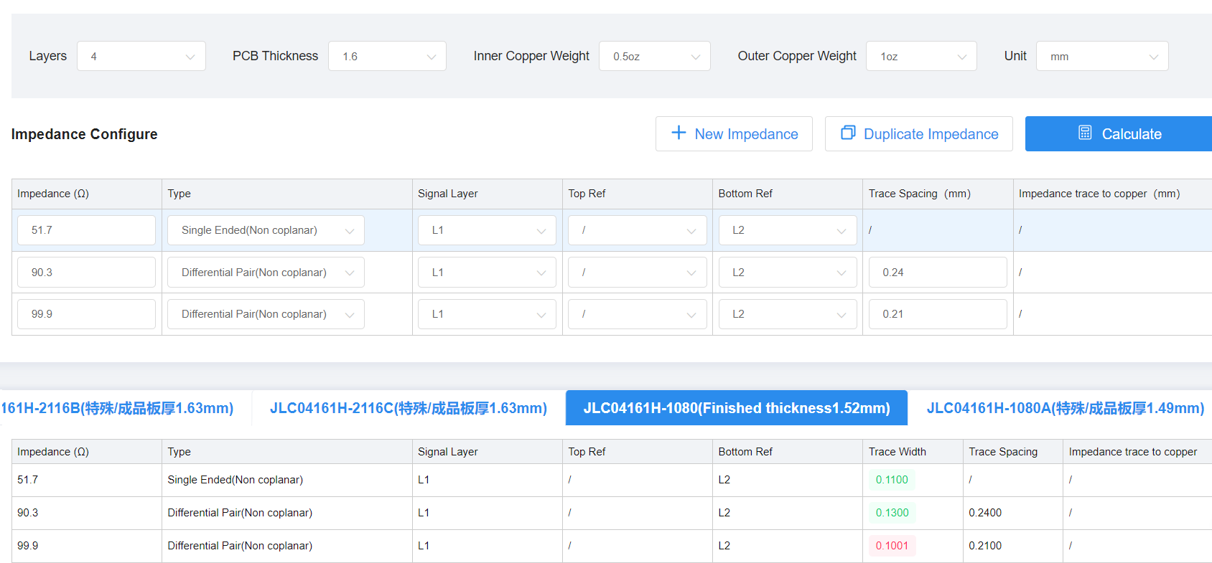

eMMC

DDR
The stub is to the resistors is not included.
Name | Trace length (mm) | Vias | Impedance resistor (ohm) | Trace width (mm) | Impedance (ohm) | Route | Spacing (mm) | Critical length (mm)
DDR_CLK_P | 48.966 | 2 | N/A | 0.09 | 97.9 | Clock | 0.14 | 1200
DDR_CLK_N | 49.305 | 2 | N/A | 0.09 | 97.9 | Clock | 0.14 | 1200
A0 | 49.304 | 2 | N/A | 0.09 | 56.2 | Address | N/A | See .xls
A1 | 48.94 | 2 | N/A | 0.09 | 56.2 | Address | N/A | See .xls
A2 | 48.398 | 2 | N/A | 0.09 | 56.2 | Address | N/A | See .xls
A3 | 48.909 | 2 | N/A | 0.09 | 56.2 | Address | N/A | See .xls
A4 | 47.259 | 2 | N/A | 0.09 | 56.2 | Address | N/A | See .xls
A5 | 47.637 | 2 | N/A | 0.09 | 56.2 | Address | N/A | See .xls
A6 | 47.021 | 2 | N/A | 0.09 | 56.2 | Address | N/A | See .xls
A7 | 46.514 | 2 | N/A | 0.09 | 56.2 | Address | N/A | See .xls
A8 | 46.199 | 2 | N/A | 0.09 | 56.2 | Address | N/A | See .xls
A9 | 48.936 | 2 | N/A | 0.09 | 56.2 | Address | N/A | See .xls
A10 | 48.367 | 2 | N/A | 0.09 | 56.2 | Address | N/A | See .xls
A11 | 47.821 | 2 | N/A | 0.09 | 56.2 | Address | N/A | See .xls
A12 | 48.45 | 2 | N/A | 0.09 | 56.2 | Address | N/A | See .xls
A13 | 46.09 | 2 | N/A | 0.09 | 56.2 | Address | N/A | See .xls
A14 | 49.17 | 2 | N/A | 0.09 | 56.2 | Address | N/A | See .xls
BA0 | 48.418 | 2 | N/A | 0.09 | 56.2 | Address | N/A | See .xls
BA1 | 47.396 | 2 | N/A | 0.09 | 56.2 | Address | N/A | See .xls
BA2 | 47.673 | 2 | N/A | 0.09 | 56.2 | Address | N/A | See .xls
CASN | 49.301 | 2 | N/A | 0.09 | 56.2 | Address | N/A | See .xls
CKE | 47.453 | 2 | N/A | 0.09 | 56.2 | Address | N/A | See .xls
CSN | 48.757 | 2 | N/A | 0.09 | 56.2 | Address | N/A | See .xls
ODT | 49.004 | 2 | N/A | 0.09 | 56.2 | Address | N/A | See .xls
RASN | 49.125 | 2 | N/A | 0.09 | 56.2 | Address | N/A | See .xls
WEN | 44.328 | 4 | N/A | 0.09 | 56.2 | Address | N/A | See .xls
DQ0 | 45.406 | 0 | N/A | 0.09 | 56.2 | Data | N/A | See .xls
DQ1 | 46.07 | 0 | N/A | 0.09 | 56.2 | Data | N/A | See .xls
DQ2 | 46.429 | 0 | N/A | 0.09 | 56.2 | Data | N/A | See .xls
DQ3 | 44.996 | 0 | N/A | 0.09 | 56.2 | Data | N/A | See .xls
DQ4 | 43.902 | 2 | N/A | 0.09 | 56.2 | Data | N/A | See .xls
DQ5 | 45.986 | 0 | N/A | 0.09 | 56.2 | Data | N/A | See .xls
DQ6 | 46.417 | 0 | N/A | 0.09 | 56.2 | Data | N/A | See .xls
DQ7 | 46.765 | 0 | N/A | 0.09 | 56.2 | Data | N/A | See .xls
DDR_DQS0_P | 45.921 | 0 | N/A | 0.09 | 97.9 | Clock | N/A | See .xls
DDR_DQS0_N | 45.875 | 0 | N/A | 0.09 | 97.9 | Clock | N/A | See .xls
DQ8 | 40.432 | 0 | N/A | 0.09 | 56.2 | Data | N/A | See .xls
DQ9 | 40.64 | 0 | N/A | 0.09 | 56.2 | Data | N/A | See .xls
DQ10 | 39.859 | 0 | N/A | 0.09 | 56.2 | Data | N/A | See .xls
DQ11 | 40.004 | 0 | N/A | 0.09 | 56.2 | Data | N/A | See .xls
DQ12 | 39.477 | 0 | N/A | 0.09 | 56.2 | Data | N/A | See .xls
DQ13 | 39.679 | 0 | N/A | 0.09 | 56.2 | Data | N/A | See .xls
DQ14 | 39.048 | 0 | N/A | 0.09 | 56.2 | Data | N/A | See .xls
DQ15 | 38.561 | 0 | N/A | 0.09 | 56.2 | Data | N/A | See .xls
DQM0 | 45.624 | 0 | N/A | 0.09 | 56.2 | Data | N/A | See .xls
DQM1 | 39.32 | 0 | N/A | 0.09 | 56.2 | Data | N/A | See .xls
DDR_DQS1_P | 40.417 | 0 | N/A | 0.09 | 97.9 | Clock | N/A | See .xls
DDR_DQS1_N | 39.429 | 0 | N/A | 0.09 | 97.9 | Clock | N/A | See .xls

PMIC

HDMI
Connection from | Pin | Connection to | Pin | Signal type | Other
STM32MP15 | AC4 | SII9022ACNU | CSCL | Clock | Pull-up
STM32MP15 | Y4 | SII9022ACNU | CSDA | Data | Pull-up
Decoupling | N/A | SII9022ACNU | IOVCC | Power | 3.3V
STM32MP15 | D3 | SII9022ACNU | D23 | Data | N/A
Decoupling + resistor | N/A | SII9022ACNU | CVCC12 | Power | 1.2V
STM32MP15 | B2 | SII9022ACNU | D22 | Data | N/A
STM32MP15 | AB5 | SII9022ACNU | D21 | Data | N/A
STM32MP15 | C2 | SII9022ACNU | D20 | Data | N/A
STM32MP15 | C5 | SII9022ACNU | D19 | Data | N/A
STM32MP15 | D5 | SII9022ACNU | D18 | Data | N/A
STM32MP15 | AA3 | SII9022ACNU | D17 | Data | N/A
STM32MP15 | AB4 | SII9022ACNU | D16 | Data | N/A
STM32MP15 | E2 | SII9022ACNU | D15 | Data | N/A
STM32MP15 | E3 | SII9022ACNU | D14 | Data | N/A
STM32MP15 | C1 | SII9022ACNU | D13 | Data | N/A
STM32MP15 | B1 | SII9022ACNU | D12 | Data | N/A
STM32MP15 | C3 | SII9022ACNU | D11 | Data | N/A
STM32MP15 | D1 | SII9022ACNU | D10 | Data | N/A
STM32MP15 | C10 | SII9022ACNU | D9 | Data | N/A
STM32MP15 | AC14 | SII9022ACNU | IDCK | Clock | N/A
STM32MP15 | AA7 | SII9022ACNU | D8 | Data | N/A
STM32MP15 | K3 | SII9022ACNU | D7 | Data | N/A
STM32MP15 | K3 | SII9022ACNU | D6 | Data | N/A
STM32MP15 | U2 | SII9022ACNU | D5 | Data | N/A
STM32MP15 | E4 | SII9022ACNU | D4 | Data | N/A
STM32MP15 | B5 | SII9022ACNU | D3 | Data | N/A
STM32MP15 | AB11 | SII9022ACNU | D2 | Data | N/A
STM32MP15 | K4 | SII9022ACNU | D1 | Data | N/A
STM32MP15 | K1 | SII9022ACNU | D0 | Data | N/A
STM32MP15 | Y12 | SII9022ACNU | DE | Enable | N/A
STM32MP15 | T1 | SII9022ACNU | HSYNC | Data | N/A
STM32MP15 | H4 | SII9022ACNU | VSYNC | Data | N/A
STM32MP15 | E1 | SII9022ACNU | SD0 | Data | N/A
STM32MP15 | AC5 | SII9022ACNU | WS | Data | N/A
STM32MP15 | A8 | SII9022ACNU | CK | Clock | N/A (Audio?)
HDMI Connector | 16 | SII9022ACNU | DSDA | Data | ESD protection
HDMI Connector | 15 | SII9022ACNU | DSCL | Clock | ESD protection
STM32MP15 | Y14 | SII9022ACNU | CEC_D | Data | N/A
STM32MP15 | AC13 | SII9022ACNU | RESET# | Reset | N/A
STM32MP15 | W1 | SII9022ACNU | INT | Interrupt | N/A
HDMI Connector | 19 | SII9022ACNU | HPD | Detection | Pull-up + ESD
Resistor 5.1K | N/A | SII9022ACNU | EXT_SWING | Adjustment | Pull-down
HDMI Connector | 12 | SII9022ACNU | TXC - | Data - | Differential
HDMI Connector | 10 | SII9022ACNU | TXC + | Data + | Differential
HDMI Connector | 9 | SII9022ACNU | TX0 - | Data - | Differential
HDMI Connector | 7 | SII9022ACNU | TX0 + | Data + | Differential
HDMI Connector | 6 | SII9022ACNU | TX1 - | Data - | Differential
HDMI Connector | 4 | SII9022ACNU | TX1 + | Data + | Differential
HDMI Connector | 3 | SII9022ACNU | TX2 - | Data - | Differential
HDMI Connector | 1 | SII9022ACNU | TX2 + | Data + | Differential
HDMI Connector | 13 | SII9022ACNU | CEC_A | Indicator | ESD

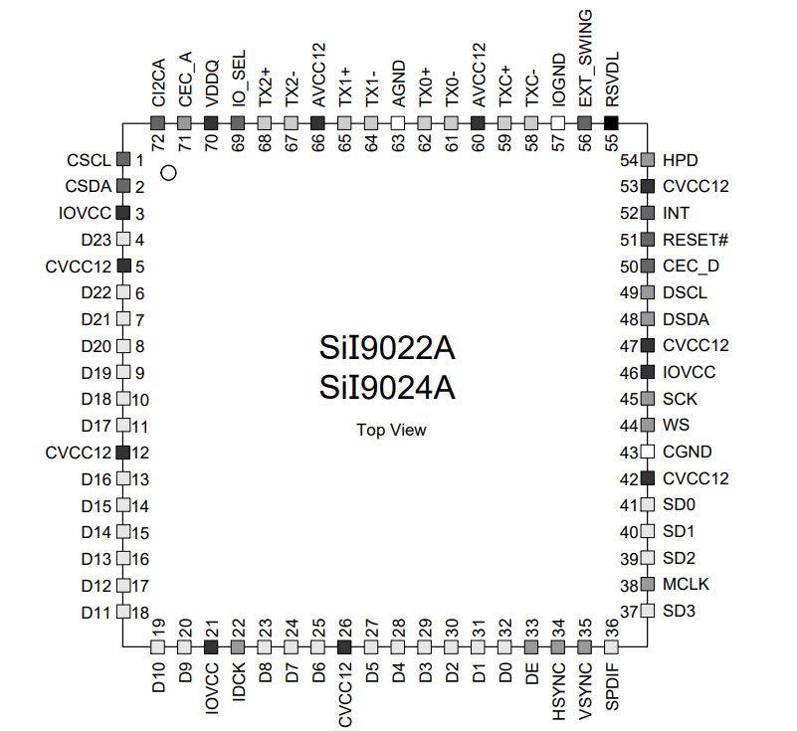

USB Host
This is USB host, 4x A-ports.
Connection from | Pin | Connection to | Pin | Signal type | Other
DM_T | T2 | USB2514B | USBDM_DN1 | Data - | Passing ECMF02-2AMX6
DP_T | T3 | USB2514B | USBDP_DN1 | Data + | Passing ECMF02-2AMX6
DM_B | B2 | USB2514B | USBDM_DN2 | Data - | Passing ECMF02-2AMX6
DP_B | B3 | USB2514B | USBDP_DN2 | Data + | Passing ECMF02-2AMX6
Decopuling | N/A | USB2514B | VDDA33 | Power | 3.3V
DM_T | T2 | USB2514B | USBDM_DN3 | Data - | Passing ECMF02-2AMX6
DP_T | T3 | USB2514B | USBDP_DN3 | Data + | Passing ECMF02-2AMX6
DM_B | B2 | USB2514B | USBDM_DN4 | Data - | Passing ECMF02-2AMX6
DP_B | B3 | USB2514B | USBDP_DN4 | Data + | Passing ECMF02-2AMX6
GND | N/A | USB2514B | TEST | NC | N/A
STMPS2252MTR | 3 | USB2514B | PRTPRW1 | Enable signal | N/A
STMPS2252MTR | 8 | USB2514B | OCS_N1 | Over current signal | N/A
100nF | N/A | USB2514B | CRFILT | Filter capacitor | N/A
Decopuling | N/A | USB2514B | VDD33 | Power | 3.3V
STMPS2252MTR | 4 | USB2514B | PRTPRW2 | Enable signal | N/A
STMPS2252MTR | 5 | USB2514B | OCS_N2 | Over current signal | N/A
STMPS2252MTR | 3 | USB2514B | PRTPRW3 | Enable signal | N/A
STMPS2252MTR | 8 | USB2514B | OCS_N3 | Over current signal | N/A
STMPS2252MTR | 4 | USB2514B | PRTPRW4 | Enable signal | N/A
STMPS2252MTR | 5 | USB2514B | OCS_N4 | Over current signal | N/A
STM32MP15 | AA19 | USB2514B | NON_REM[1] | Data | Pull-up/down
STM32MP15 | Y18 | USB2514B | CFG_SEL[0] | Clock | Pull-up/down
N/A | N/A | USB2514B | CFG_SEL[1] | Config | Pull-up/down
N/A | N/A | USB2514B | RESET_N | Reset | Pull-up 10K
N/A | N/A | USB2514B | VBUS_DET | Config | Pull-up 10K
LED | N/A | USB2514B | NON_REM[0] | Config | Pull-down 10K
STM32MP15 | AB17 | USB2514B | USBDM_DP | Data - | Differential
STM32MP15 | AC17 | USB2514B | USBDP_DP | Data + | Differential
NX2016SA | 1 | USB2514B | XTALOUT | Crystal 24 MHz | 0R resistor + decoplings
NX2016SA | 3 | USB2514B | XTALIN | Crystal 24 MHz | 0R resistor + decoplings
100nF | N/A | USB2514B | PLLFILT | Filter capacitor | N/A
Resistor | N/A | USB2514B | RBIAS | Config | Pull-down 12K

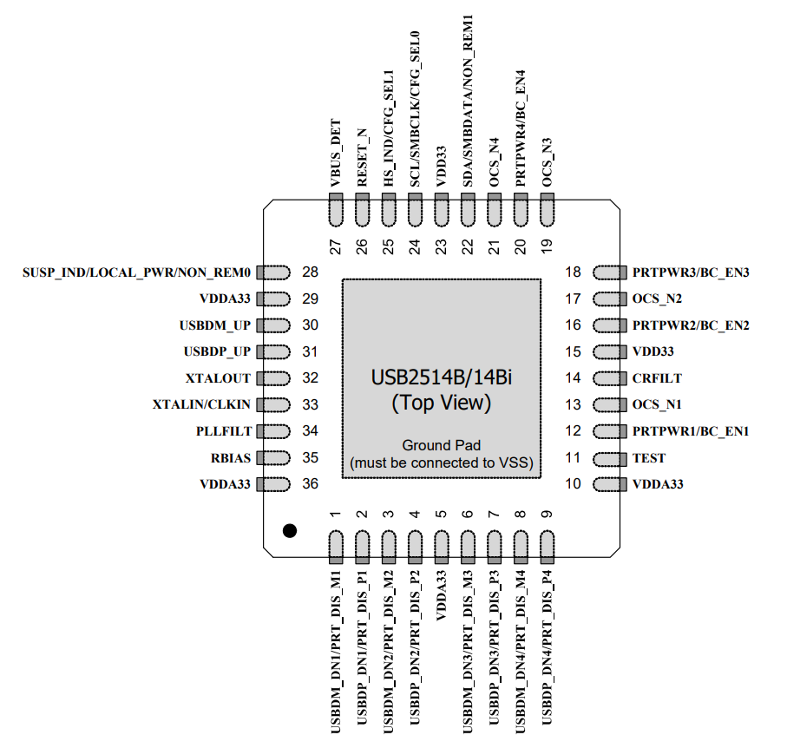
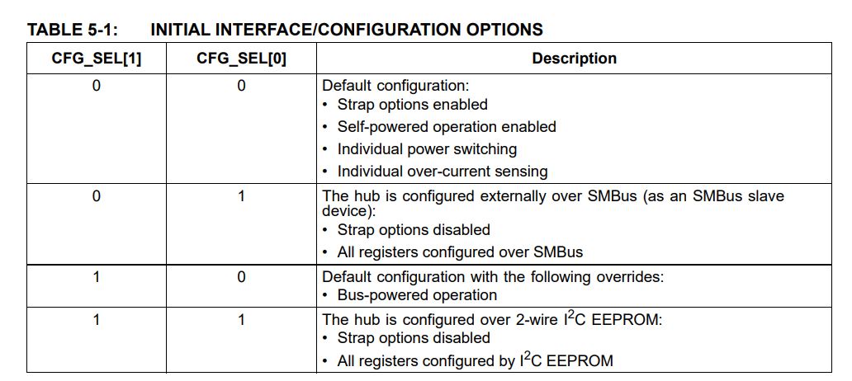

RX/TX rise time: ns.
Name | Trace length (mm) | Vias | Impedance resistor (ohm) | Trace width (mm) | Impedance (ohm) | Route | Spacing (mm) | Critical length (mm)
USBDM_DN1 | 12.401 | 0 | N/A | 0.13 | 90.3 | Data - | 0.24 | N/A
USBDP_DN1 | 12.503 | 0 | N/A | 0.13 | 90.3 | Data + | 0.24 | N/A
USBDM_DN2 | 15.88 | 0 | N/A | 0.13 | 90.3 | Data - | 0.24 | N/A
USBDP_DN2 | 15.88 | 0 | N/A | 0.13 | 90.3 | Data + | 0.24 | N/A
USBDM_DN3 | 15.308 | 0 | N/A | 0.13 | 90.3 | Data - | 0.24 | N/A
USBDP_DN3 | 15.338 | 0 | N/A | 0.13 | 90.3 | Data + | 0.24 | N/A
USBDM_DN4 | 20.578 | 0 | N/A | 0.13 | 90.3 | Data - | 0.24 | N/A
USBDP_DN4 | 20.578 | 0 | N/A | 0.13 | 90.3 | Data + | 0.24 | N/A
USBDM_UP | 32.487 | 0 | N/A | 0.13 | 90.3 | Data - | 0.24 | N/A
USBDP_UP | 32.434 | 0 | N/A | 0.13 | 90.3 | Data + | 0.24 | N/A

Reduced Gigabit Media-Independent Interface (RGMII)
The Reduced Gigabit Media-Independent Interface (RGMII) is using the twisted pair cable 1000BASE-T. The connections between the processor STM32MP15XXAC and Ethernet PHY Realtek RTL8211F-CG are:
Connection from | Pin | Connection to | Pin | Signal type | Other
J0G-0001NL | 11 | RTL8211F-CG | MPIP0 | Data + | Differential
J0G-0001NL | 10 | RTL8211F-CG | MPIN0 | Data - | Differential
Decopuling + ferrite | N/A | RTL8211F-CG | AVDD10 | Power | 1.05V
J0G-0001NL | 4 | RTL8211F-CG | MPIP1 | Data + | Differential
J0G-0001NL | 5 | RTL8211F-CG | MPIN1 | Data - | Differential
J0G-0001NL | 3 | RTL8211F-CG | MPIP2 | Data + | Differential
J0G-0001NL | 2 | RTL8211F-CG | MPIN2 | Data - | Differential
J0G-0001NL | 8 | RTL8211F-CG | MPIP3 | Data + | Differential
J0G-0001NL | 9 | RTL8211F-CG | MPIN3 | Data - | Differential
Decopuling + ferrite | N/A | RTL8211F-CG | AVDD33 | Power | 3.3V
Pull-up 10K | N/A | RTL8211F-CG | PHYRSTB | Hardware Reset | 3.3V
STM32MP15 | AA6 | RTL8211F-CG | MDC | Clock | Pull-up 1.5K
STM32MP15 | AC3 | RTL8211F-CG | MDIO | Data | Pull-up 1.5K
STM32MP15 | Y1 | RTL8211F-CG | TXD3 | Data | N/A
STM32MP15 | Y2 | RTL8211F-CG | TXD2 | Data | N/A
STM32MP15 | AA1 | RTL8211F-CG | TXD1 | Data | N/A
STM32MP15 | AA2 | RTL8211F-CG | TXD0 | Data | N/A
STM32MP15 | AB1 | RTL8211F-CG | TXCTL | Control | N/A
STM32MP15 | AB2 | RTL8211F-CG | TXC | Clock | N/A
Decopuling + ferrite | N/A | RTL8211F-CG | DVDD10 | Power | 1.05V
STM32MP15 | W4 | RTL8211F-CG | RXD3 | Data | Impedance resistor + pull-up 4.7K
STM32MP15 | AB6 | RTL8211F-CG | RXD2 | Data | Impedance resistor + pull-down 4.7K
STM32MP15 | AB7 | RTL8211F-CG | RXD1 | Data | Impedance resistor + pull-up 4.7K
STM32MP15 | AC7 | RTL8211F-CG | RXD0 | Data | Impedance resistor + pull-up 4.7K
STM32MP15 | AB8 | RTL8211F-CG | RXCTL | Control | Zero ohm resistor + pull-down 4.7K
STM32MP15 | AA4 | RTL8211F-CG | RXC | Clock | Zero ohm resistor + pull-down 4.7K
Decopuling + ferrite | N/A | RTL8211F-CG | DVDD_RG | Power | N/A
Decopuling + ferrite | N/A | RTL8211F-CG | DVDD | Power | N/A
2.2µH or 4.7µH inductor | N/A | RTL8211F-CG | REG_OUT | Regulator | 1.05V
STM32MP15 | AC8 (ej int) | RTL8211F-CG | INTB | External interupt | Pull-up 1.5K
LED Green | N/A | RTL8211F-CG | CFG_EXT | Config | Pull-up 4.7K
LED Yellow | N/A | RTL8211F-CG | CFG_LD0 | Config | Pull-down 4.7K
LED Green | N/A | RTL8211F-CG | CFG_LD1 | Config | Pull-down 4.7K
STM32MP15 | Y6 | RTL8211F-CG | CLKOUT | Clock 125MHz | Impedance resistor
NX3225GA | 1 | RTL8211F-CG | XTAL_IN | Crystal 25MHz | 0R resistor + decoplings
NX3225GA | 3 | RTL8211F-CG | XTAL_OUT | Clock 25MHz | 0R resistor + decoplings
2.49K resistor | N/A | RTL8211F-CG | RSET | Regulator reference | 2.49K pull-down

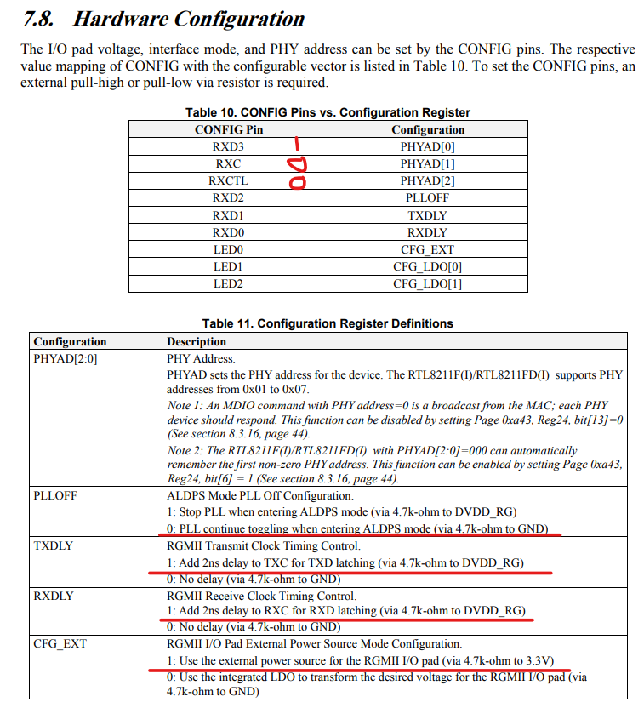

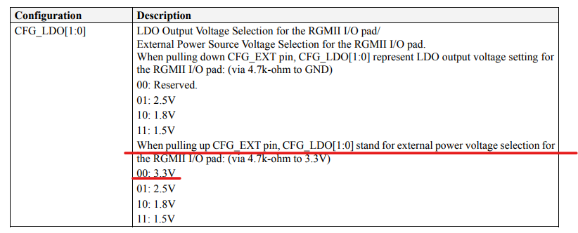
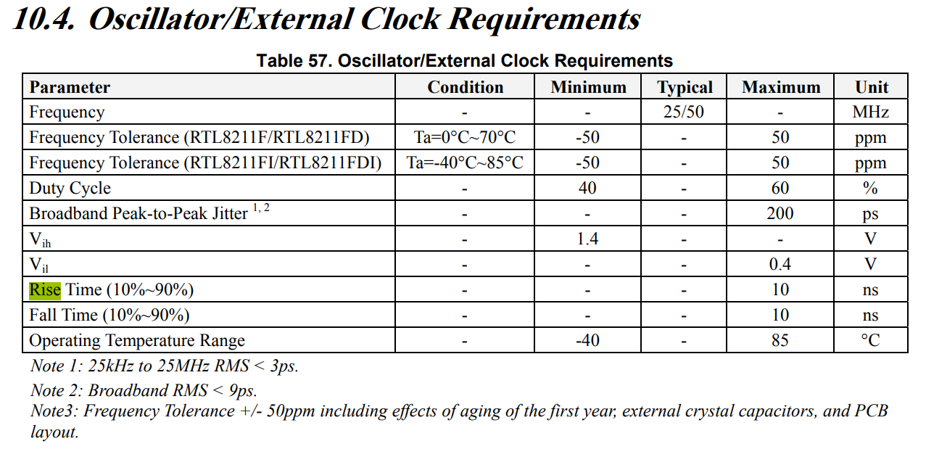

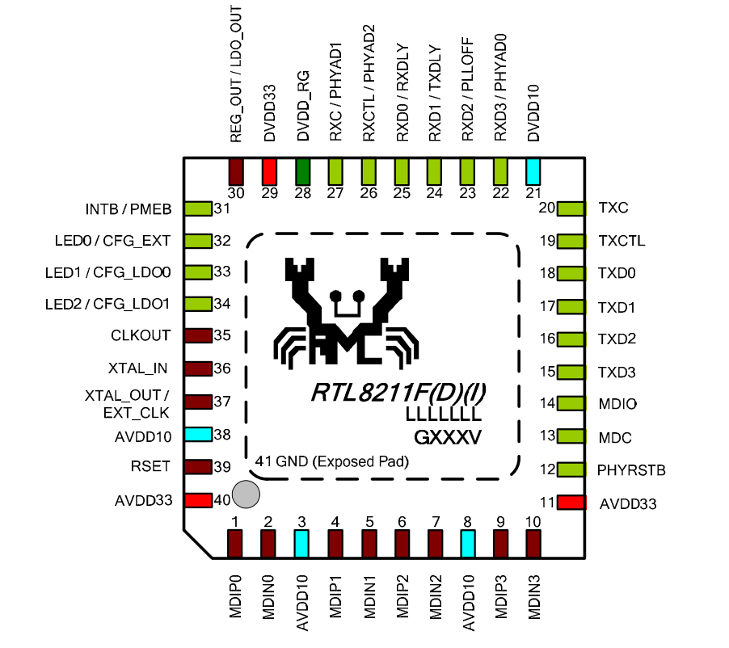
Impedance
RX/TX rise time: ns.
Name | Trace length (mm) | Vias | Impedance resistor (ohm) | Trace width (mm) | Impedance (ohm) | Route | Spacing (mm) | Critical length (mm)
ETH_GTX_CLK | 21.011 | 0 | N/A | 0.11 | 51.7 | Single  Non coplanar | N/A | 28.447
ETH_TX_EN | 20.962 (17.762) | 2 | N/A | 0.11 | 51.7 | Single  Non coplanar | N/A | 28.447
ETH_TXD0 | 20.936 (17.736) | 2 | N/A | 0.11 | 51.7 | Single  Non coplanar | N/A | 28.447
ETH_TXD1 | 20.947 (17.747) | 2 | N/A | 0.11 | 51.7 | Single  Non coplanar | N/A | 28.447
ETH_TXD2 | 20.906 (17.706) | 2 | N/A | 0.11 | 51.7 | Single  Non coplanar | N/A | 28.447
ETH_TXD3 | 20.987 (17.787) | 2 | N/A | 0.11 | 51.7 | Single  Non coplanar | N/A | 28.447
ETH_RX_CLK | 29.286 (24.486) | 3 | 0 | 0.11 | 51.7 | Single  Non coplanar | N/A | 28.447
ETH_RX_DV | 29.280 (24.480) | 3 | 0 | 0.11 | 51.7 | Single  Non coplanar | N/A | 28.447
ETH_RXD0 | 29.121 (24.321) | 3 | 22 | 0.11 | 51.7 | Single  Non coplanar | N/A | 28.447
ETH_RXD1 | 29.110 (24.310) | 3 | 22 | 0.11 | 51.7 | Single  Non coplanar | N/A | 28.447
ETH_RXD2 | 29.158 (24.358) | 3 | 22 | 0.11 | 51.7 | Single  Non coplanar | N/A | 28.447
ETH_RXD3 | 29.127 (24.327) | 3 | 22 | 0.11 | 51.7 | Single  Non coplanar | N/A | 28.447
RJ45_D4 | P 26.841  N 28.545 | 0 | N/A | 0.1 | 99.9 | Differential  Non coplanar | 0.21
RJ45_D3 | P 26.467  N 27.035 | 0 | N/A | 0.1 | 99.9 | Differential  Non coplanar | 0.21
RJ45_D2 | P 28.046  N 29.751 | 0 | N/A | 0.1 | 99.9 | Differential  Non coplanar | 0.21
RJ45_D1 | P 21.775  N 22.343 | 0 | N/A | 0.1 | 99.9 | Differential  Non coplanar | 0.21

